## Appendix C – Timing and RF signal distribution at Bleik community house

Updated 2024-08-26

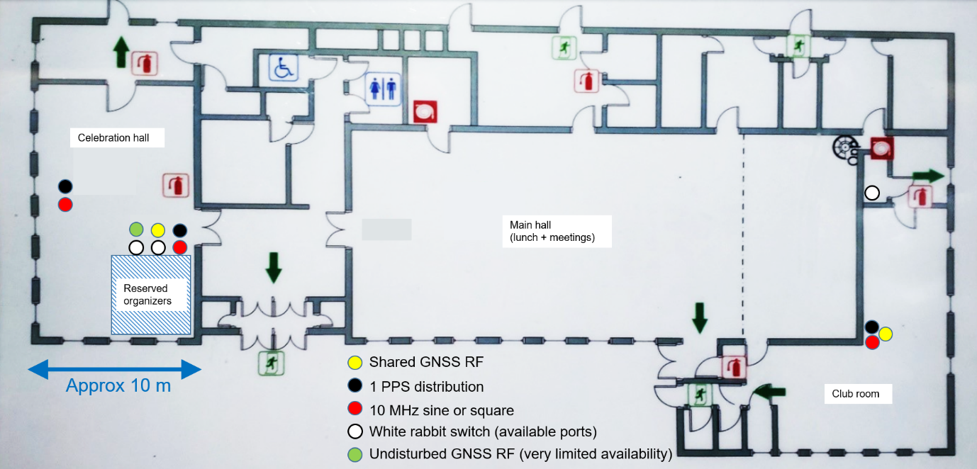

Reference timing signals will be available in the ‘Celebration hall’ and ‘Club room’ at Bleik community house. RF signals from a shared antenna

**GNSS RF distribution**

Reference antenna: Novatel GNSS-750 positioned outside the community house (exact position TBD). The antenna gain is approx. 41 dB. Cable loss is approx. 5-6 dB (dependent on antenna location).

The distribution system consists of a Tallysman 4 port active splitter, with a net gain of 0 dB on each port. The RF signal is further split into 4 16-port passive splitters, with a net loss of 12 dB per port. Net gain per port will be approximately 24 dB from the Novatel antenna in ‘celebration hall’. In ‘club room’ the gain will be reduced a few dB more from cable loss (TBD).

There will be 38 ports available in ‘celebration hall’, and 16 ports available in ‘club room’. All unused ports will be terminated with a 50 ohm dummy load. The splitter connector is of type N female. TNC and SMA adapters could be provided if critical. All ports available are DC blocked, and terminated internally with a 200 ohm resistor to simulate a GNSS antenna preamplifier load.

**Timing sources**

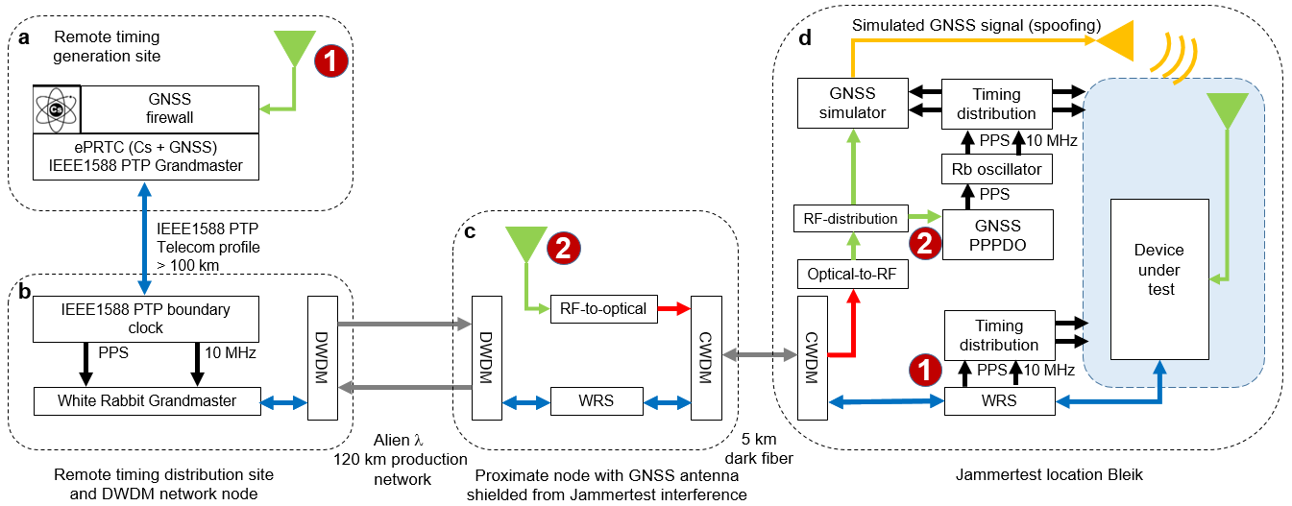

There are two sources of timing available at Bleik community house:

(1) ePRTC class timing over a combination of standard IEEE1588 and White Rabbit PTP. The timing source is a Cs-clock backed ePRTC made available by Telenor. Timing is transported over standard PTP in Telenor’s sync backbone and over White Rabbit PTP in the Norwegian national research DWDM network (Sikt) and finally over a dedicated CWDM bidirectional channel to Bleik community house. Anticipated ePRTC performance is within +/- 30 ns from UTC (after calibration). Performance in 2023 was likely within +/- 10 ns (albeit without a careful calibration).

(2) GNSS timing using RF signals over optical fiber from an antenna at a nearby location shielded from Jammertest RF interference. The remote GNSS signal is fed to a prototype disciplined OCXO using the Fugro AtomiChron PPP timing service. Anticipated timing performance is within +/- 5 ns from UTC after calibration.

**Timing signal distribution**

Timing signals will be distributed as electrical signals: pulse-per-second, 10 MHz sine and 10 MHz square. There are also opportunities to connect to available ports on White Rabbit switches.

**Physical signal distribution characteristics**

Distribution amplifiers: Microsemi 9611

Connectors: BNC

PPS: 0 – 2 V into 50 Ohm with a rise time of approx 20 ns

10 MHz square: 0 – 2 V into 50 Ohm with a rise time of approx 20 ns

10 MHz sine: 3 Vp-p into 50 Ohm

This appendix will be updated with pulse delay calibration values for the rising edge of PPS signals for the distribution amplifiers deployed.

**Connection to White Rabbit switches**

There is opportunity to connect PTP devices (standard or White Rabbit) to available ports on White Rabbit switches in the Celebration Hall and the Club room. The organizers cannot offer extensive support for this, but we will do our best. Please bring your own SFPs and (rugged) fiber cables, preferable something already known to work. Consult the list of tested SFPs and fiber types here: <https://ohwr.org/project/white-rabbit/-/wikis/sfp.>

**‘Celebration Hall’ – timing signal availability**

* Two or three racks with physical timing signal distribution with a total of 84 outputs configurable in blocks of 12.
* PPS from ePRTC and Fugro AtomiChron
* 10 MHz sine
* 10 MHz square
* Available ports on White Rabbit switch(es)

**‘Club room’ - timing signal availability**

* One rack (possibly two) with physical timing signal distribution with a total of 48 outputs configurable in blocks of 12
* PPS from White Rabbit switch (following either ePRTC or AtomiChron timing source)
* 10 MHz square from White Rabbit switch ((following either ePRTC or AtomiChron timing source)
* Available ports on the White Rabbit switch